FBI Crime Data Reporting and NIBRS Adoption Rate Analysis (Final Draft)
Srinivasan Poonkundran | INFO511 Final Project Report | Mar 24, 2025
Research Question and Purpose
Research Question:
How do agency types vary across different states in the USA, and what percentage of agencies in each state participate in NIBRS reporting? Are there observable trends in NIBRS adoption over time?
Purpose:
This project explores trends in U.S. law enforcement agencies, focusing on agency types (City, County, Other) and their participation in the FBI’s National Incident-Based Reporting System (NIBRS).

Dataset Information
The dataset that is used in this project is obtained from TidyTuesday^{[1]}. The dataset contains information about the law enforcement agencies reporting to the FBI’s Uniform Crime Reporting (UCR) Program. This dataset has 19,166 entries with data such as agency name, type, location (latitude/longitude, state, county), NIBRS (National Incident-Based Reporting System) participation status, and start date of participation.
The data we have is an agency level data across all the 50 states in United States. This data sets provides the details on law enforcement agencies that have submitted data to the FBI’s Uniform Crime Reporting Program and are displayed on the Crime Data Explorer.

Data Preprocessing and Cleaning
Several preprocessing steps were performed to handle missing values and standardize data:
- Latitude & Longitude: 1,947 entries (~10%) had missing coordinates. Missing values were filled using the average latitude/longitude of the respective state. Additionally, invalid values (e.g., minimum latitude of -9.0) were identified and removed.
- Agency Type: ~9% of entries had missing agency types. These were imputed based on agency names (e.g., agencies containing “Sheriff” were classified as County agencies, while those with “Police” were classified as City agencies). Remaining missing values were labelled as “Other”.
- NIBRS Start Date: This column had ~21% missing values. The median start date was used to fill missing values where appropriate, while maintaining the integrity of temporal analysis. The column was also converted to a datetime format for accurate time-series analysis.

Exploratory Data Analysis (EDA) and Visualizations:
EDA was performed to identify key trends and insights:
- Distribution of Agency Types by State: The dataset predominantly consists of City and County agencies, with visualization highlighting their distribution across states.

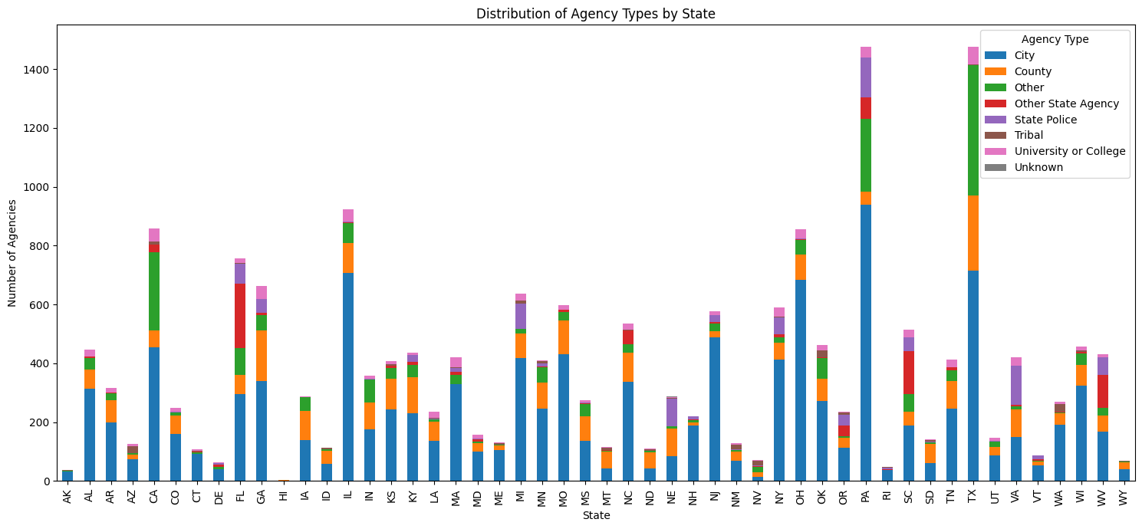
Distribution of Agency Types by State
This plot shoes a clear representation of how law enforcement agencies are spread across the U.S. In this stacked bar chart, each bar represents one state and is divided into three segments based on agency types: City, County, and Other. This plot shows that the city agencies like police department takes the largest portion in most of the states. The second most common type of agencies according to the above plot are County based agencies. States with greater population and urban areas tend to have longer bars than others.
- Overall Distribution of Agency Types

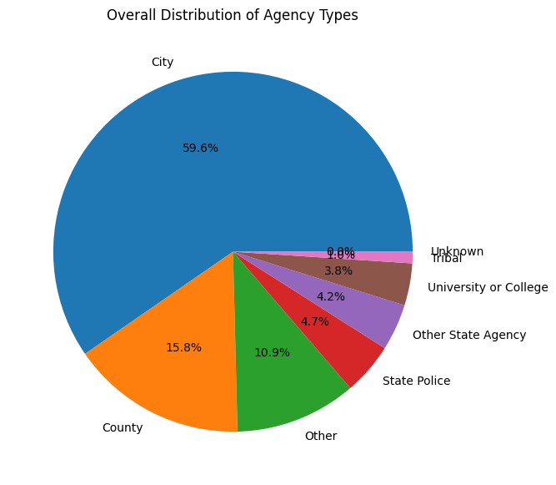
This plot gives a country wise summary of how law enforcement agencies are categorized. This pie chart shows that the major agencies across the United States are classified as City agencies. This includes police departments. Overall, this plot gives a summarized information of what that was given by the ‘’Distribution of Agency Types by State” plot.
- Trend of NIBRS adoption over time.
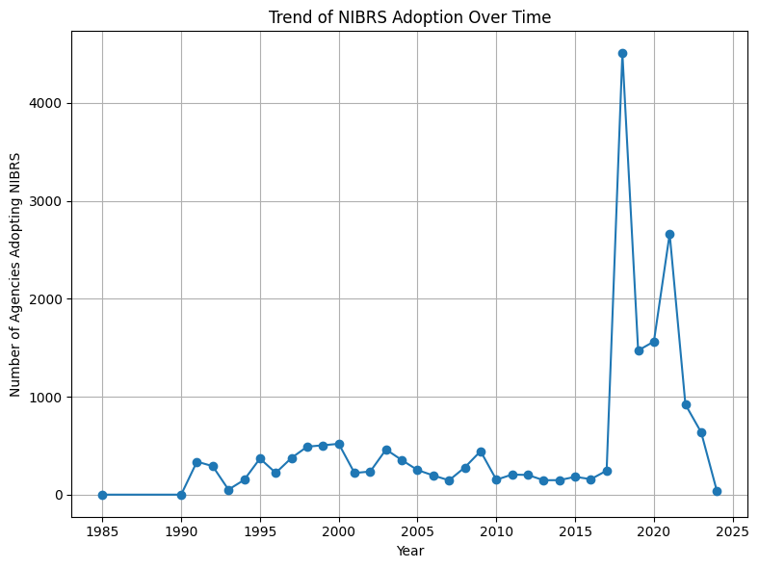
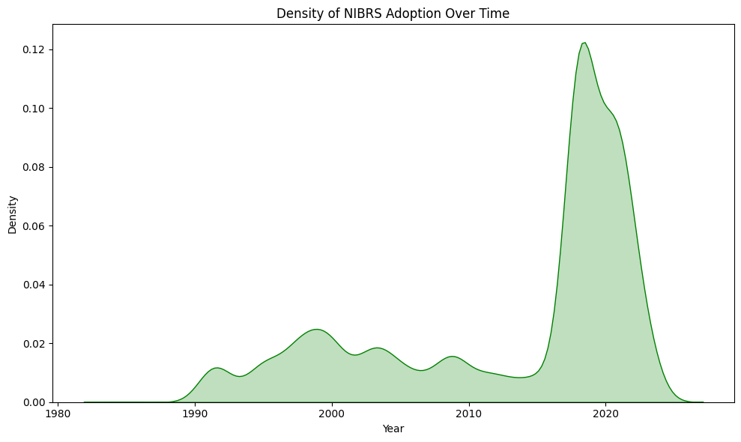
This plot shows how the number of law enforcement agencies reporting crime data through the National Incident-Based Reporting System (NIBRS) has changed year by year. The plot uses a line chart where each point shows the number of agencies that started using NIBRS in a specific year.

In the late 90’s, the line stays at 0 or near 0 which states that there were no to very few agencies who adopted NIBRS at that time. As time went by, we can see a rise showing a gradual increase in participation. There are few noticeable spikes where the adoption rate jumps sharply. This could correspond to specific policies, federal pushes, or incentives encouraging agencies to join NIBRS during those years or could be an outlier.

We went ahead and found that there has been a lot of policy change due to which we can see the spike^{[2]}. The overall trend clearly shows growing acceptance and use of NIBRS reporting over time. It reflects how law enforcement agencies gradually transitioned to this system.

- NIBRA Participation Rates by State
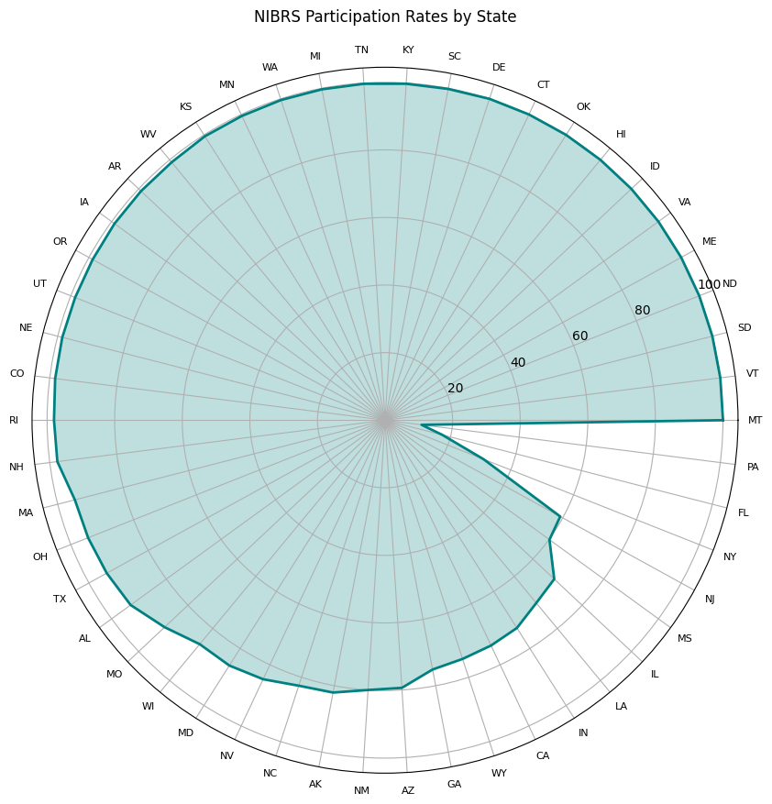

This radial plot shows the NIBRS participation rates for each U.S. state. Each state is arranged around the circle, and the fill indicates how many agencies in that state are reporting their data through NIBRS. You can see that most states have bars reaching close to the outer edge, meaning they have high participation rates. A few states have much shorter bars, showing lower participation. The circular design makes it easy to compare states side by side and quickly spot which ones are leading or lagging in NIBRS reporting.

Results
The analysis says that the agency types vary significantly across different states in the USA. City agencies are the most common type of agencies in the country, followed by County agencies. States that have larger population and urban centres tend to have more City agencies. Whereas, rural states centres tend to have more County agencies. Regarding the NIBRS participation, the percentage of agencies reporting through NIBRS differs across states. Some states have full participation while some are lagging behind according to the available data. Over time, we can see a clear upward trend in the participation data and noticeable spikes during specific periods. We found that this happened due to various policy changes ^{[2]}. Overall, these findings highlight both the structural differences in law enforcement across the country and the progressive, although uneven, but move toward standardized crime data reporting.
Conclusion
This project successfully provides a detailed look at how law enforcement agencies are structured across the United States and how they are participating in NIBRS. It clearly shows that City agencies are the most common, NIBRS participation is uneven across states, and adoption rates have improved over time. These results can help policymakers, law enforcement leaders, and researchers understand where improvements are needed and how they can support to achieve standardization in crime data reporting.
Future Recommendations
- Investigate Why Some Agencies or States Lag in Participation: Further research should focus on understanding why certain states or specific agency types (like County or Other agencies) have lower NIBRS adoption rates. This may involve looking at operational challenges, budget limitations, or administrative hurdles.
- Link Crime Data with Agency Types: Another future step is to analyse whether there’s any relationship between agency type and the crime data reported. For example, do City agencies report certain types of crimes more frequently than County agencies? This analysis could offer deeper insights into crime patterns and reporting effectiveness.
Researcher Bio-Sketch
Name: Srinivasan Poonkundran
Email: srinivasanp@arizona.edu
University / Degree: The University of Arizona / M.S. in Data Science
Course: INFO 511: Foundations of Data Science.
Role: Data cleaning, analysis, visualization, report writing.
GitHub: You can find the entire code for this project here.
Generative AI Usage Acknowledgement
I used OpenAI’s ChatGPT to assist with plotting maps (check on GitHub) and Radial chart. Other coding and visualization tasks were independently completed.
References
[1] R-FOR-DATA-SCIENCE. (2025, February 18). Agencies from the FBI Crime Data API [Dataset]. GitHub. https://github.com/rfordatascience/tidytuesday/tree/main/data/2025/2025-02-18
[2] Federal Bureau of Investigation. (n.d.). National Use-of-Force Data Collection. FBI. Retrieved March 24, 2025, from https://www.fbi.gov/how-we-can-help-you/more-fbi-services-and-information/ucr/use-of-force
Peer review recommendations response
Original Peer Review:
Excellent research question and approach to answer the question. What do you think could be negative implications on the results if you impute the mode for the missing start data? Could this have negative outcomes on the reporting. Think through how other factors may be meaningfully related to start date and see if you can impute using regregression. I would recommend trying this and seeing if the outcomes are significantly different. You will be able to see if the regression modeming for imputation is better. Make sure that all interpretations are related to inference modeming and that metrics for meaningful evaluation and impact are reported. Descriptive statistics are only describing what the data is doing and cannot make relational inference. Excellent presentation. The outcomes could be very useful for engagement with agencies.
Response:
Recommendation: Consider using regression-based imputation for missing nibrs_start_date values instead of median or mode.
Accepted/Rejected: Rejected
Reason: The project’s goal was descriptive analysis. I was found that median imputation was sufficient for identifying broad trends. Regression-based imputation would add unnecessary complexity without changing the overall insights or affecting the final results.
Recommendation: Explore whether other variables meaningfully relate to nibrs_start_date to improve imputation accuracy.
Accepted/Rejected: Rejected
Reason: The missing values were few, and the imputation did not affect key findings. Investigating variable relationships for imputation was outside the project’s scope and timeline.
Recommendation: Ensure interpretations are tied to inference modelling, and use metrics to evaluate model impact.
Accepted/Rejected: Rejected
Reason: This project was not inferential modelling focused and more focused on data exploration. No causal or predictive claims were made, so inference metrics were not applicable.

